Assignment – 1

• Install Power BI Desktop and share the final screenshot of the report view page which appears when power desktop starts.

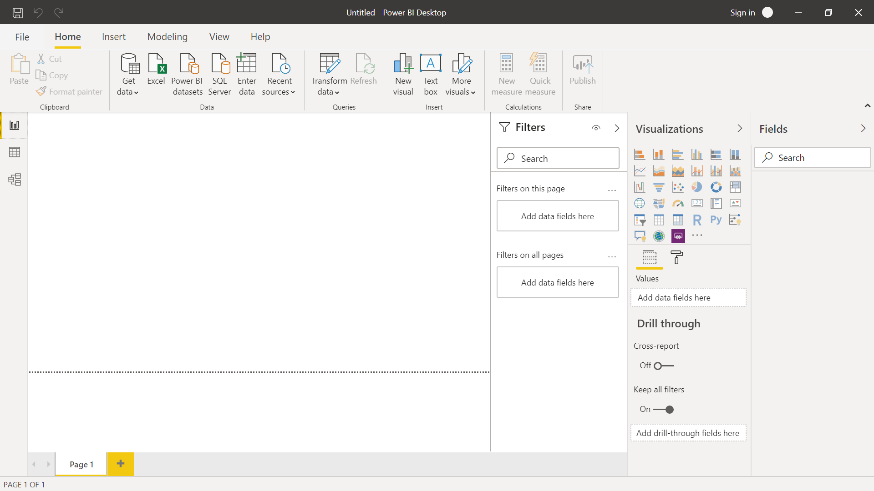

• Prepare a document and with the following screenshot − Report View − Data View − Model View − Power Query Editor − Advance Editor



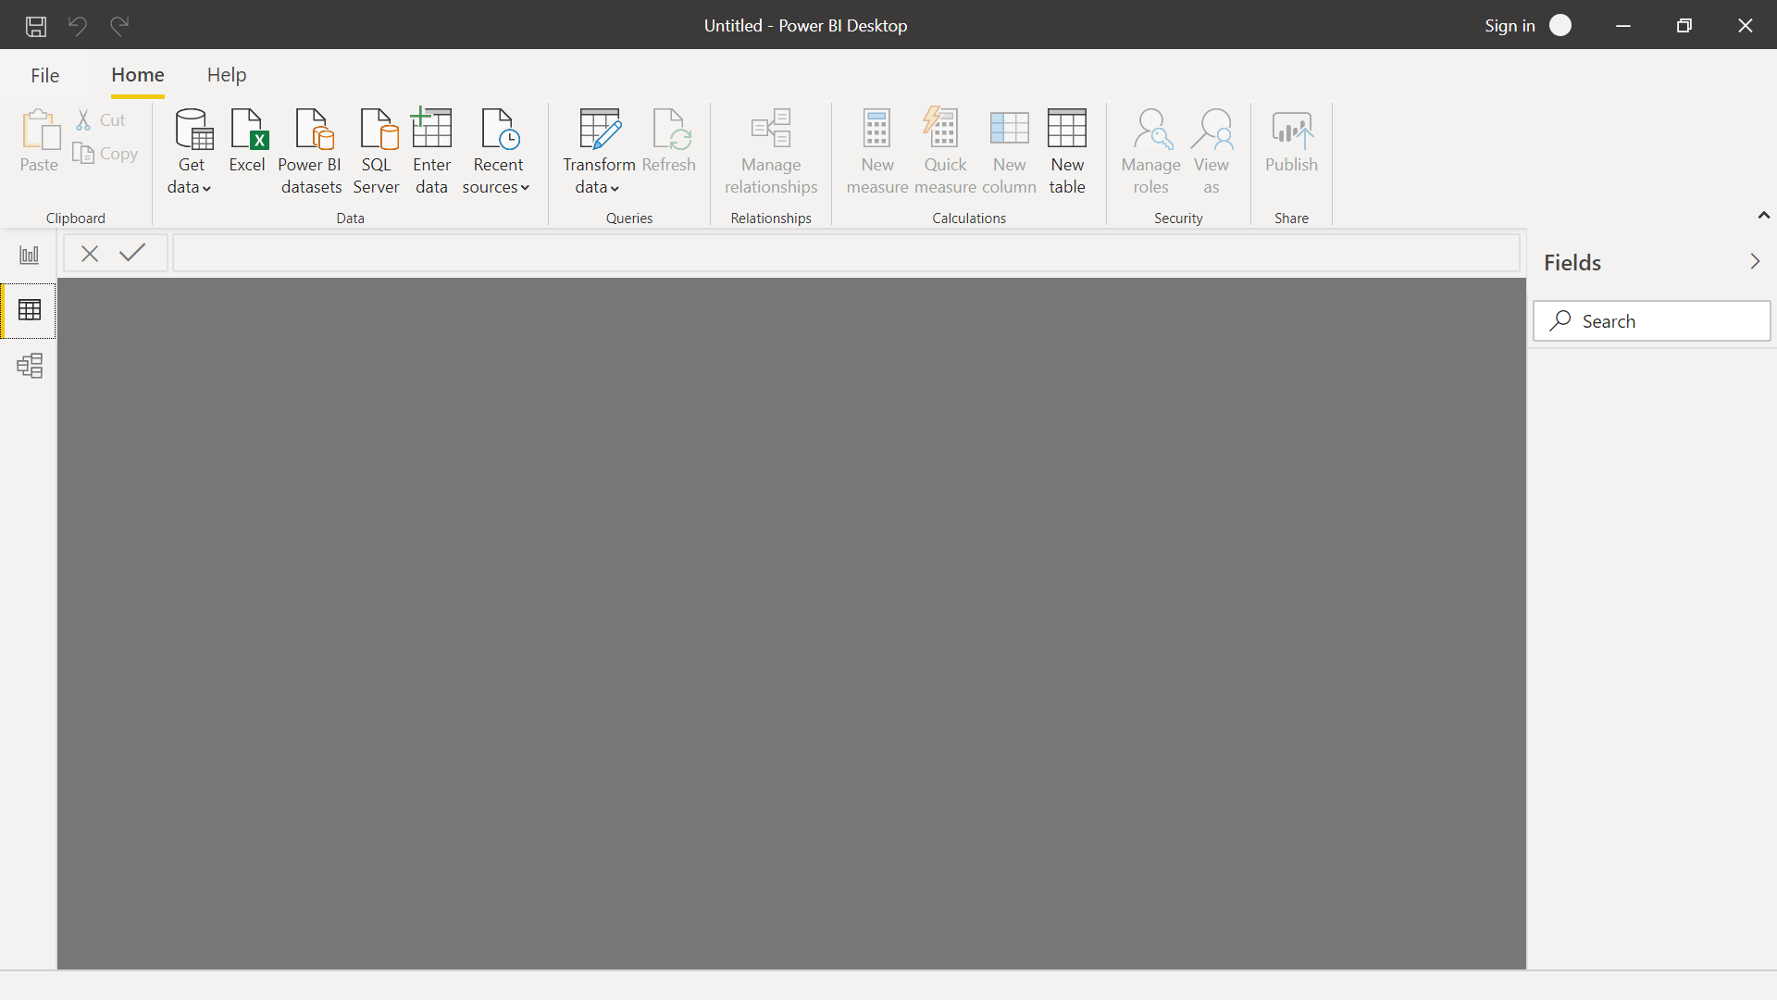

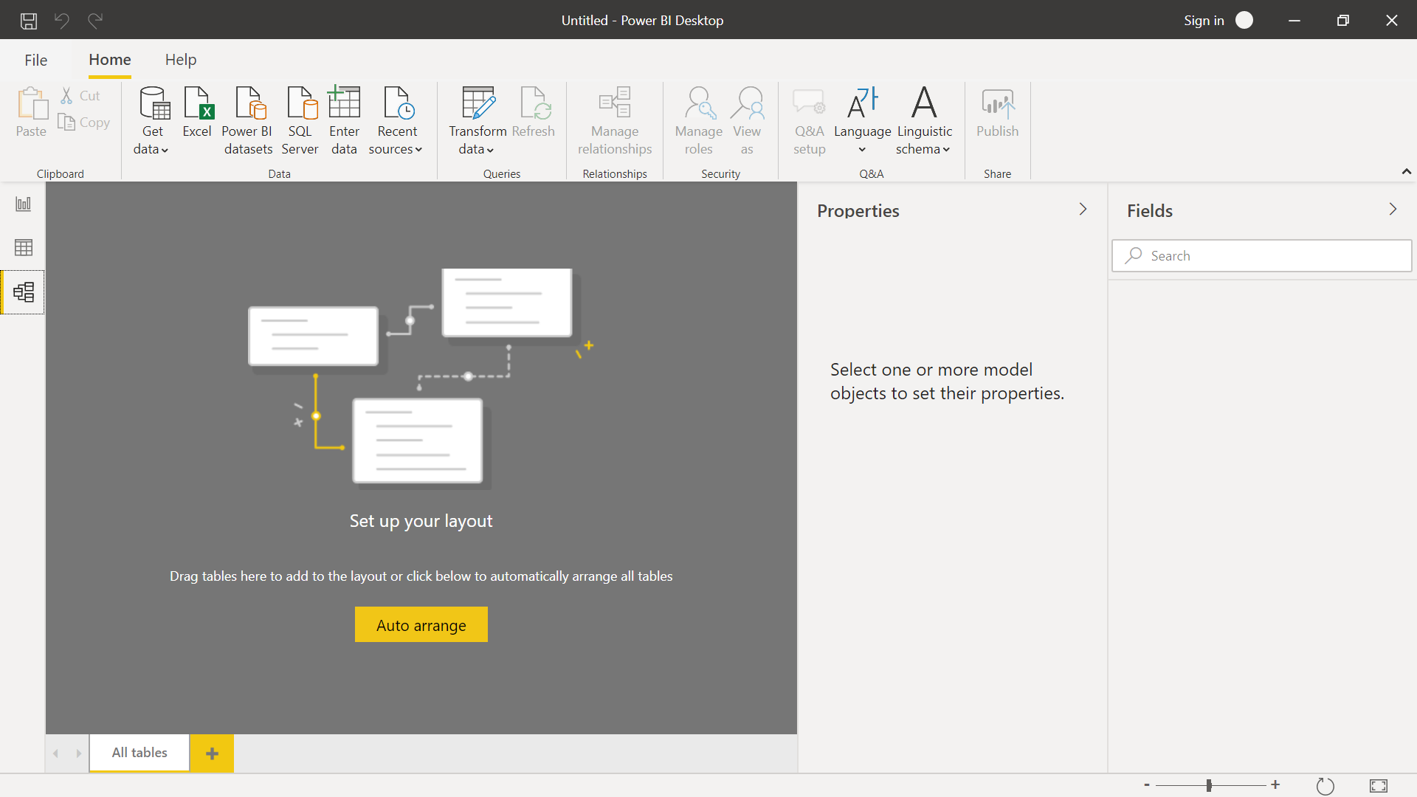

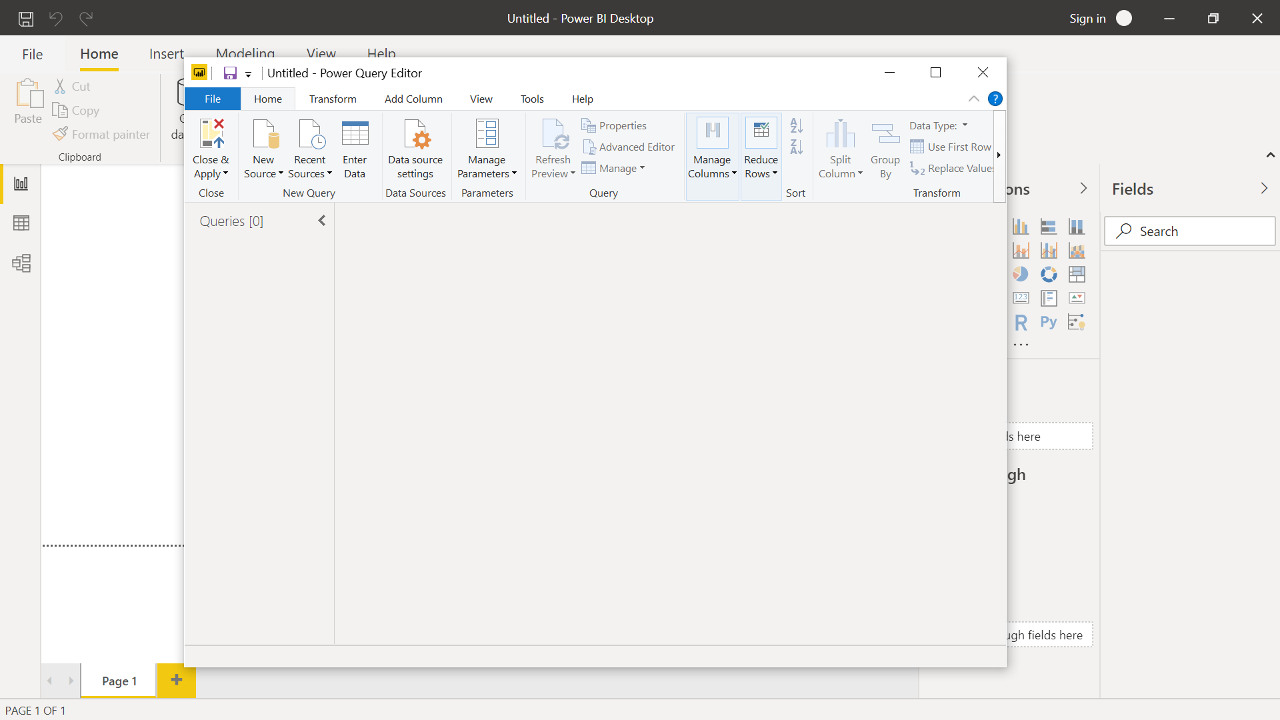

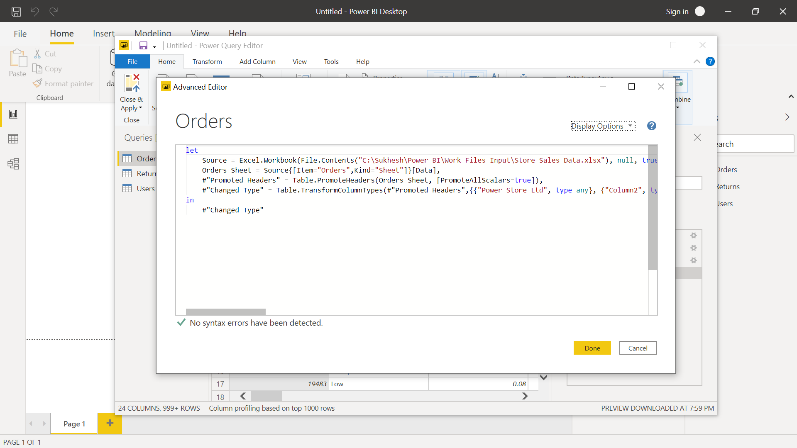

• Prepare a document with details of the following along with their price − Power BI Desktop − Power BI Pro − Power BI Premium

